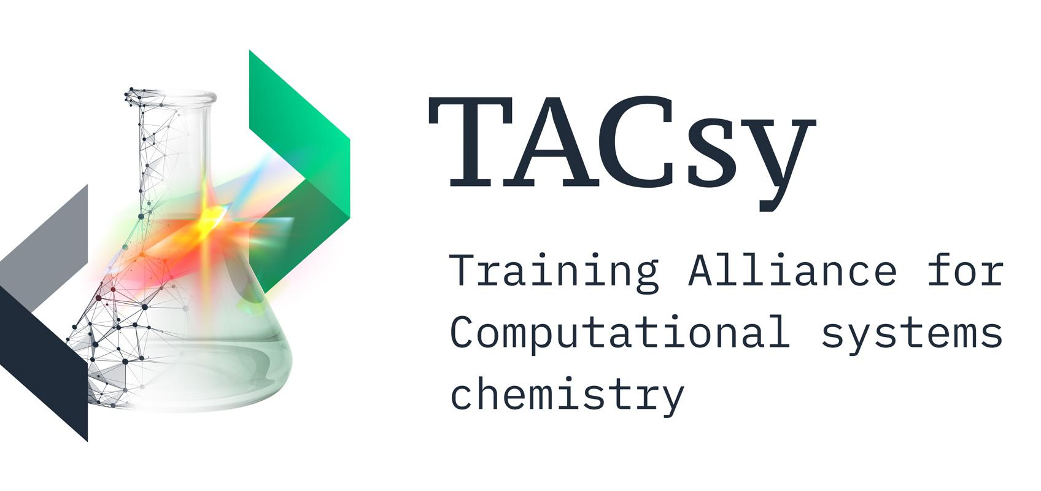
TACsy Application Form

Full Name:

MSCA candidates must not have resided in the country of the first recruitment institution for more than twelve months within three years prior to employment date (expected 1 Sept 2023). List each country of residence and months you resided there, from Aug 2020 until today, and anticipated country of residence from today until Aug 2023.

Country / Countries of Residence from September 2020 - August 2023:

Apply for up to three (3) DC positions. Indicate with 1 - 3, with 1 as the strongest preference.

__ DC 1: Efficient Graph Canonicalization & Subgraph Finding Approaches for TAC Graphs
First recruitment: Denmark or Germany

__ DC 2: Semigroup Theory for Computational Systems Chemistry
First recruitment: Denmark or Germany

__ DC 3: From formal behavioral specifications of chemical systems to their chemical Implementation
First recruitment: Germany or Austria

__ DC 4: Rule inference - Converting 200 years of chemistry knowledge to graph transformation rules
First recruitment: Germany or Denmark

__ DC 5: Machine Learning for Automated Synthesis Planning
First recruitment: Austria or Germany

__ DC 6: Dynamical systems theory for generative chemistries
First recruitment: Germany or Austria

__ DC 7: Quantum Mechanics and Chemical Graph Transformation
First recruitment: Denmark or Germany

__ DC 8: Causality Analysis for Systems Chemistry
First recruitment: Denmark or Germany

__ DC 9: Bridging the Gap from Quantum Chemistry to Rule-based Generative Chemistry for IR Reaction Cascades
First recruitment: Denmark or Germany

__ DC 10: Design of Multienzyme Cascades Based on Declarative Descriptions: Novel Computational Approaches
First recruitment: Austria or Denmark

__ DC 11: Design of Novel Pathways for Production of Bio-Based Chemicals in MECs
First recruitment: Austria

__ DC 12: Pathway Design for Chemical Upgrading and Co-factor Recycling with Cell Extracts
First recruitment: Austria

__ DC 13: Computational Lipidomics and Mass Spectrometry - Learning Mechanistical Models
First recruitment: Denmark or Austria

DC 14 position has already been filled.
*DC 15 position: apply directly to the University of Sheffield, link available Jan/Feb 2023. Mobility restrictions do not apply for DC15.

